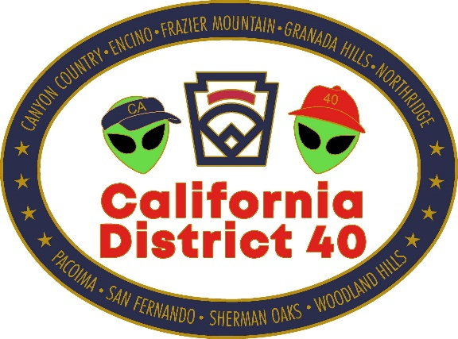

PO Box 8565
Northridge, CA 91327

Jocelyn Welch
District Administrator

To: Intermediate Baseball District Champions
Re: Intermediate Baseball Section 2 Tournament
Welcome to our District. California District 40 with Encino Little League will be your host during the 2026 Section 2 Tournament. Encino Little League is located at 5120 Hayvenhurst Ave, Encino, CA.
Enclosed you will find:
- Tournament schedule
- Tournament guidelines

If you have any questions, I can be contacted on my cell phone at (818) 414-2165 or by
e-mail at CAD40LLDA@gmail.com. As usual, we are looking forward to a great tournament season in all Divisions of Section 2.

Good luck and have fun.
Sincerely,
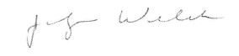
Jocelyn Welch
District Administrator
District 40

